**Jenkins server:** In this example we are running docker-compose based Jenkins server which will run on port 8083.

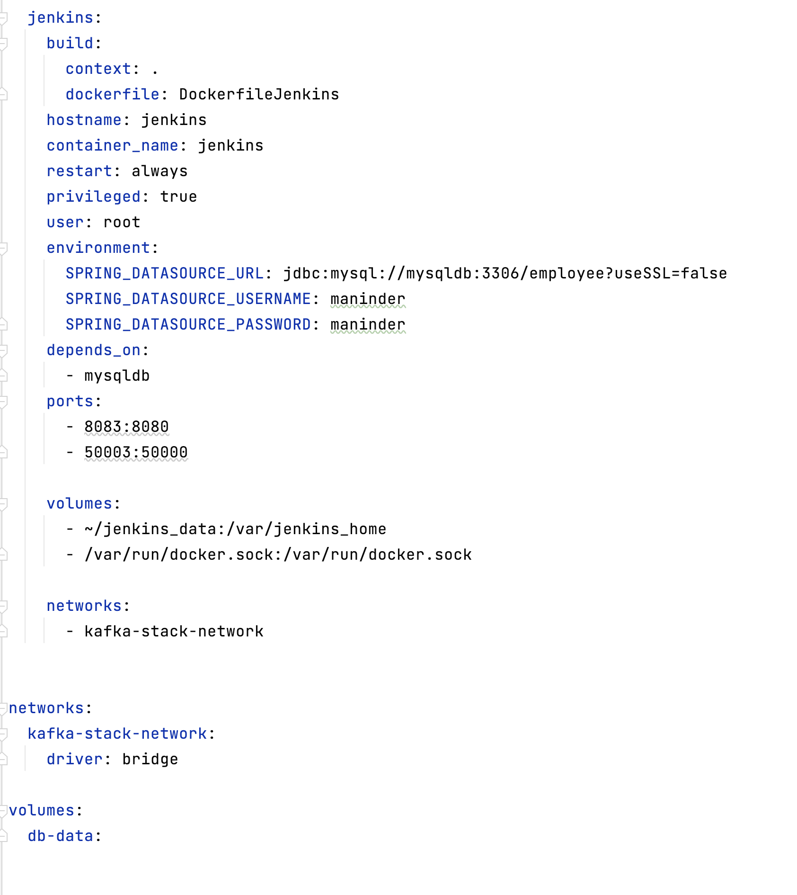

Once Jenkins Server is up, we need to do some basic configuration.

1. Hit the URL: “localhost:8083” as our Jenkins server running on this port.
2. Click on suggested plugins and give your normal information.
3. Inside the dashboard there is an option for “new Item”

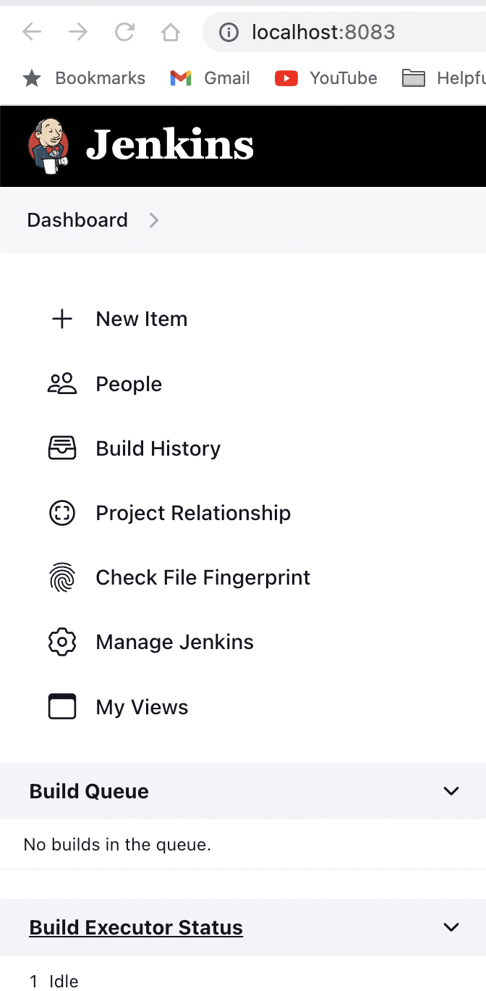

1. Click on “**New Item**” and give any name and select “**pipeline**” option, if you want to run the pipeline.
2. Our pipeline is created. Now, we need to add credentials for Github or Docker for wherever we needed.
3. Go to “**Dashboard-> Manage Jenkins->Manage Credentials**.”
4. Click on “**System->Global credentials**”.
5. Click on Add Credentials and add it.
6. Provide the Github credentials (username and password) and save it:

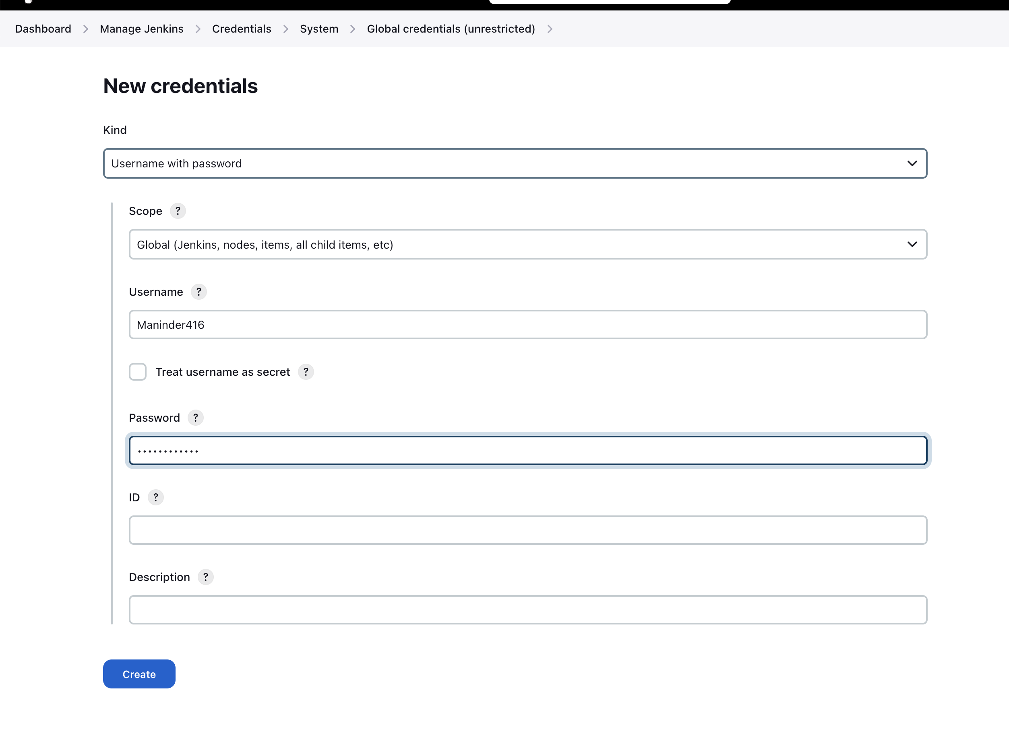

1. It will show like this:

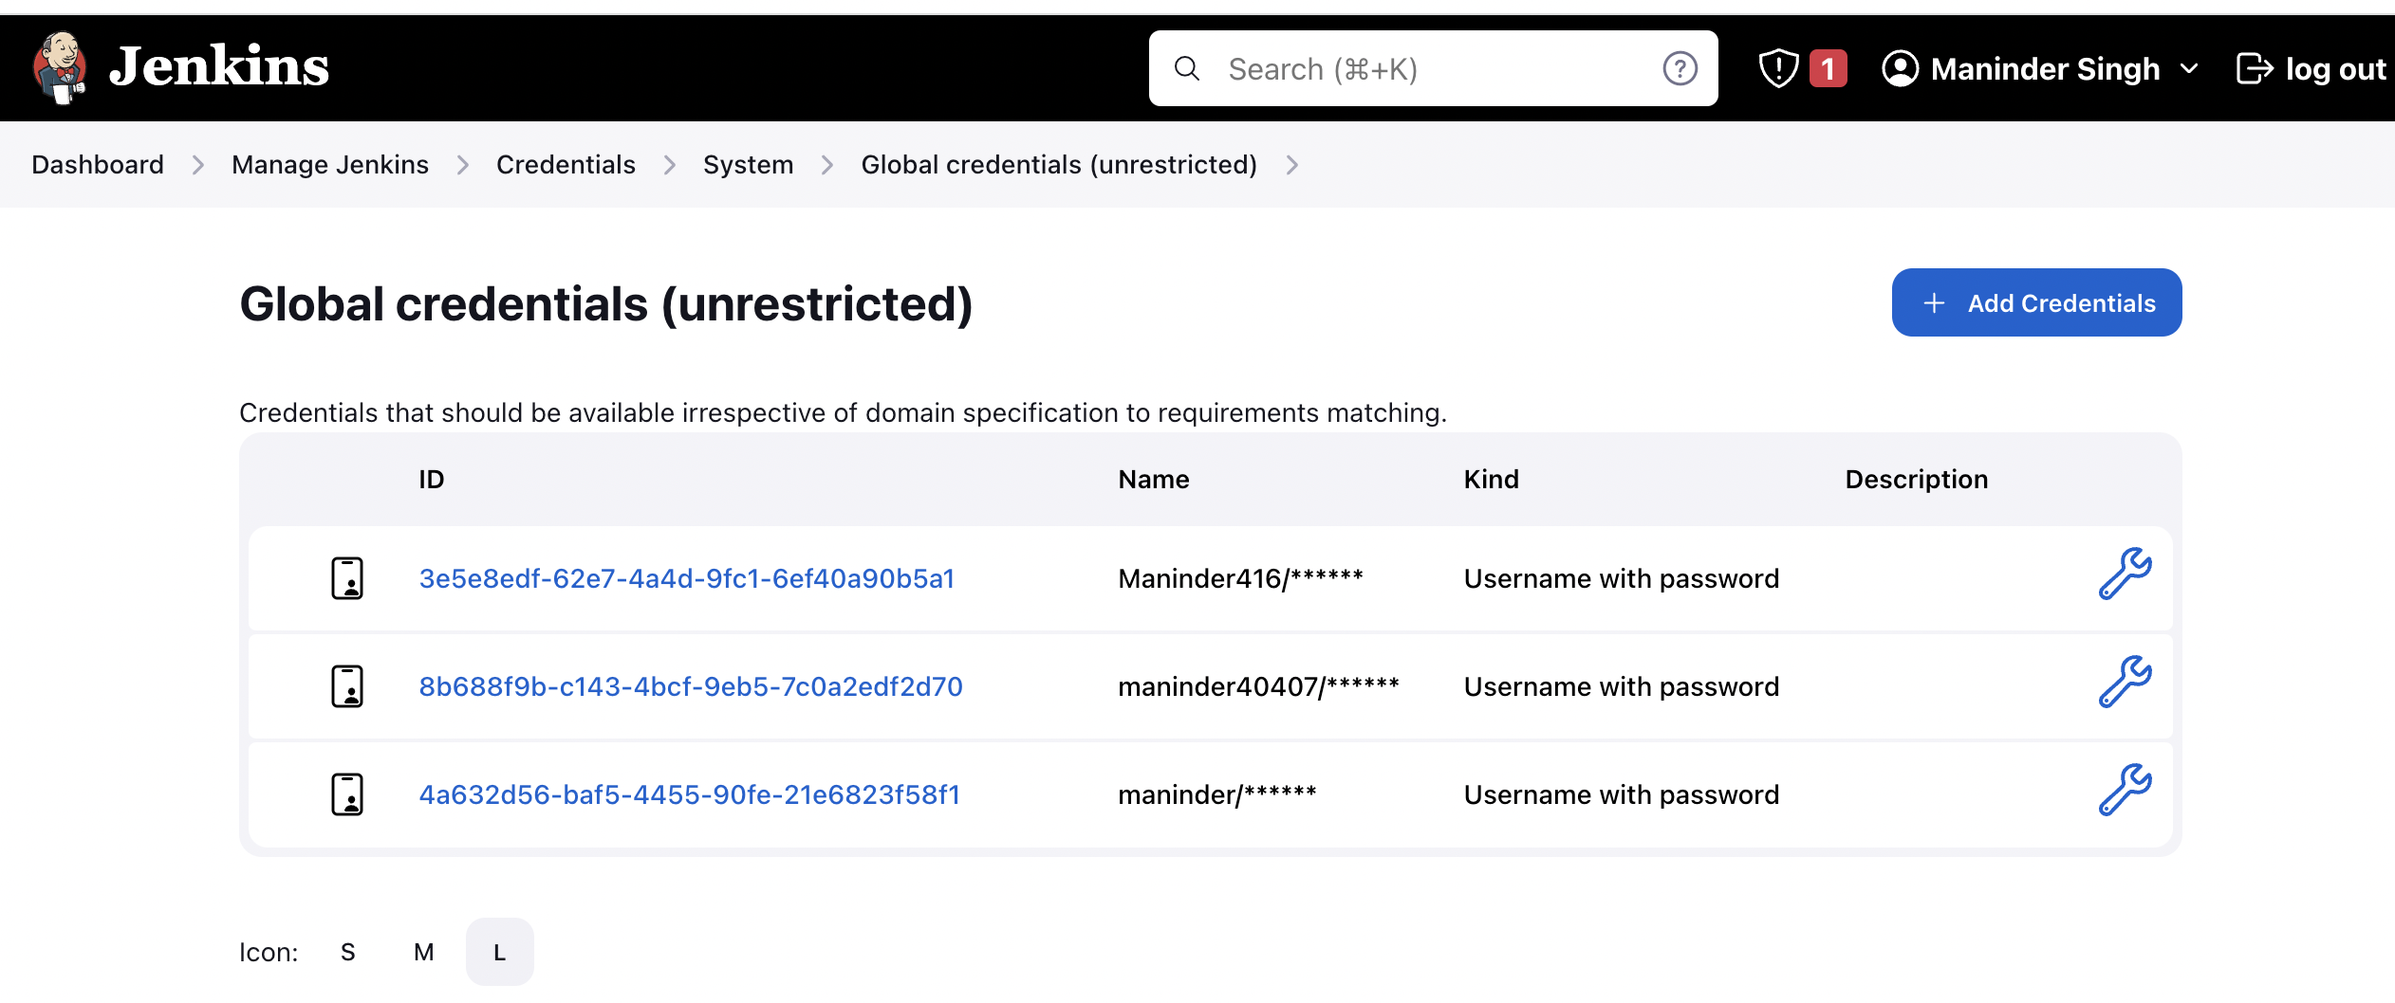

1. Now, go inside your pipeline you created above from dashboard window.
2. Click on “configure” button inside your pipeline.

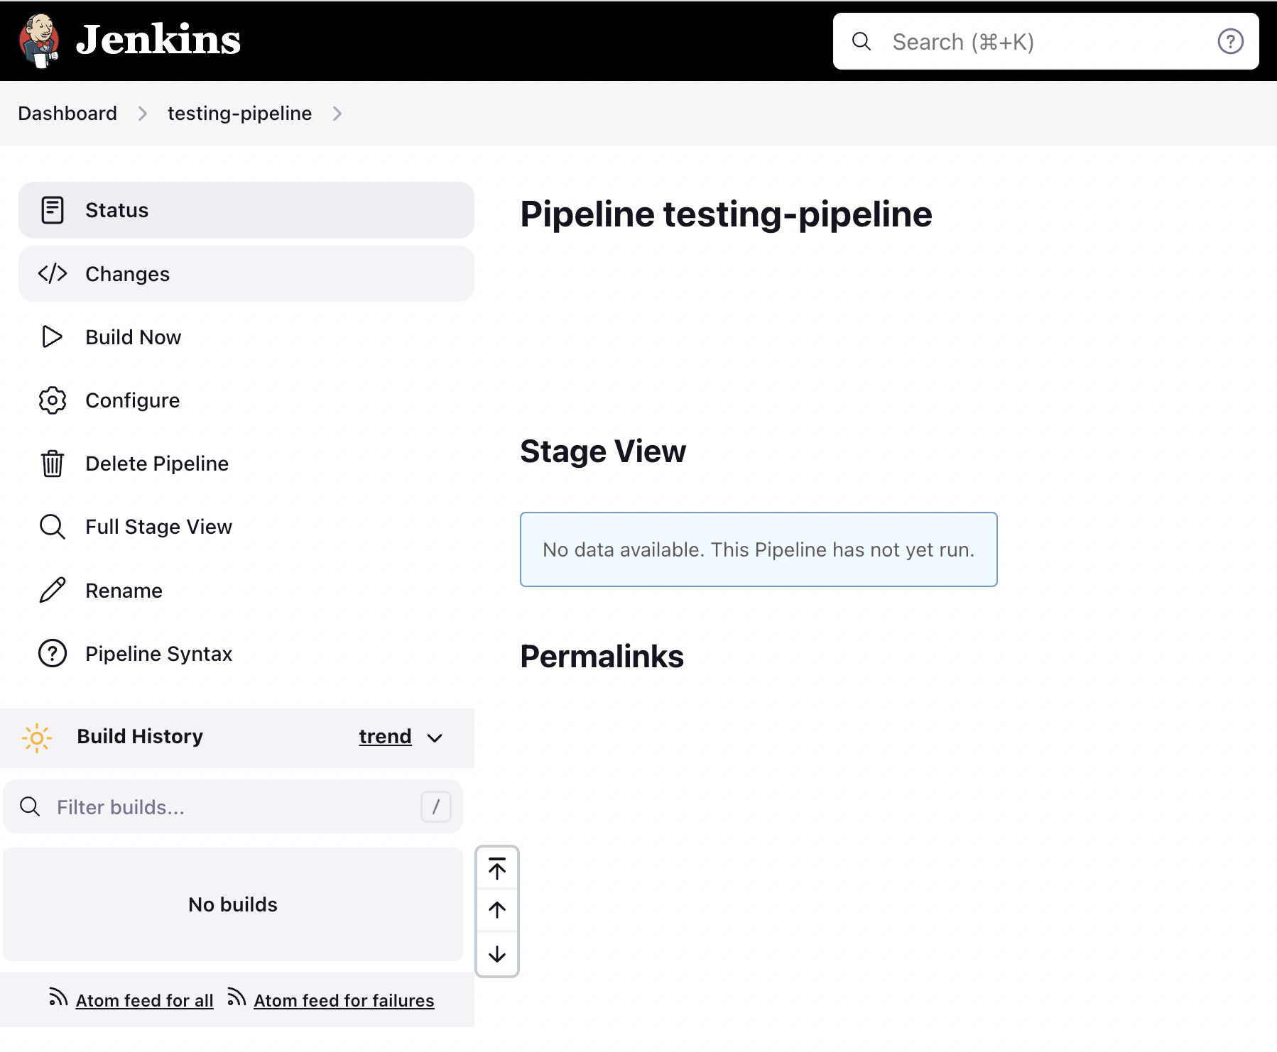

1. Inside the new window, under “**Pipeline**” section, choose “**Pipeline script from SCM**” and **SCM** as “Git.” Provide the repository details and branch name and save it.

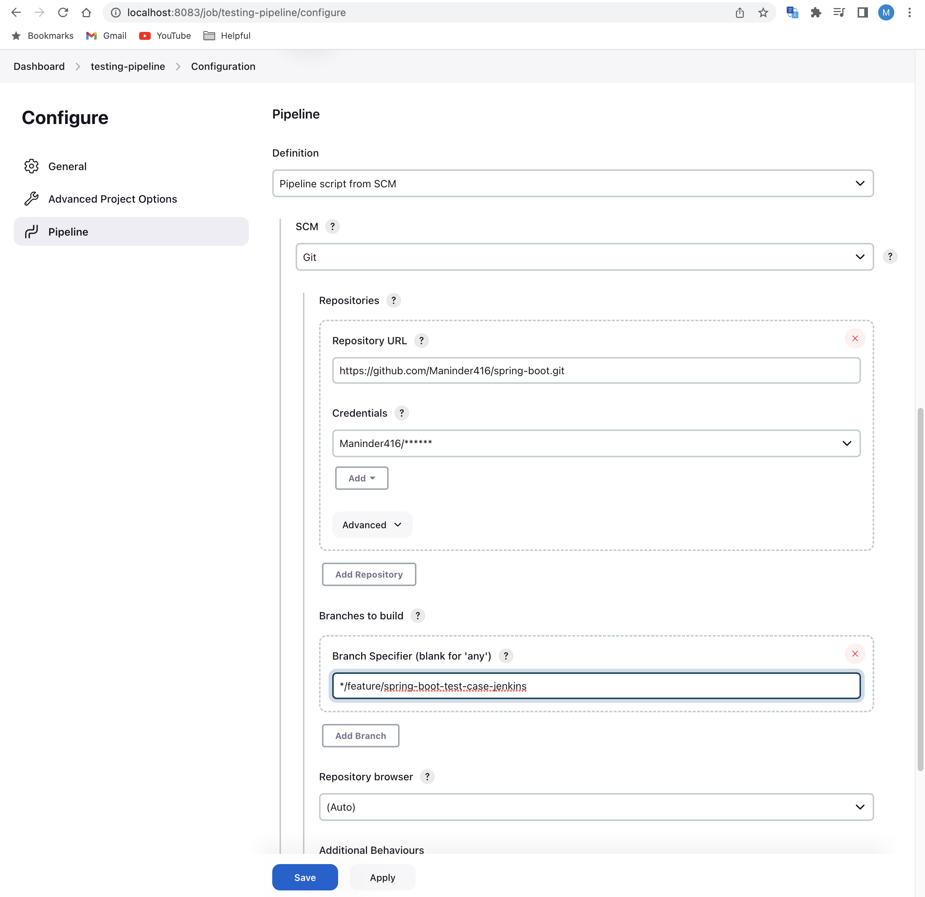

6. your pipeline is ready. Just create the Jenkins file inside your spring boot app and push the code.

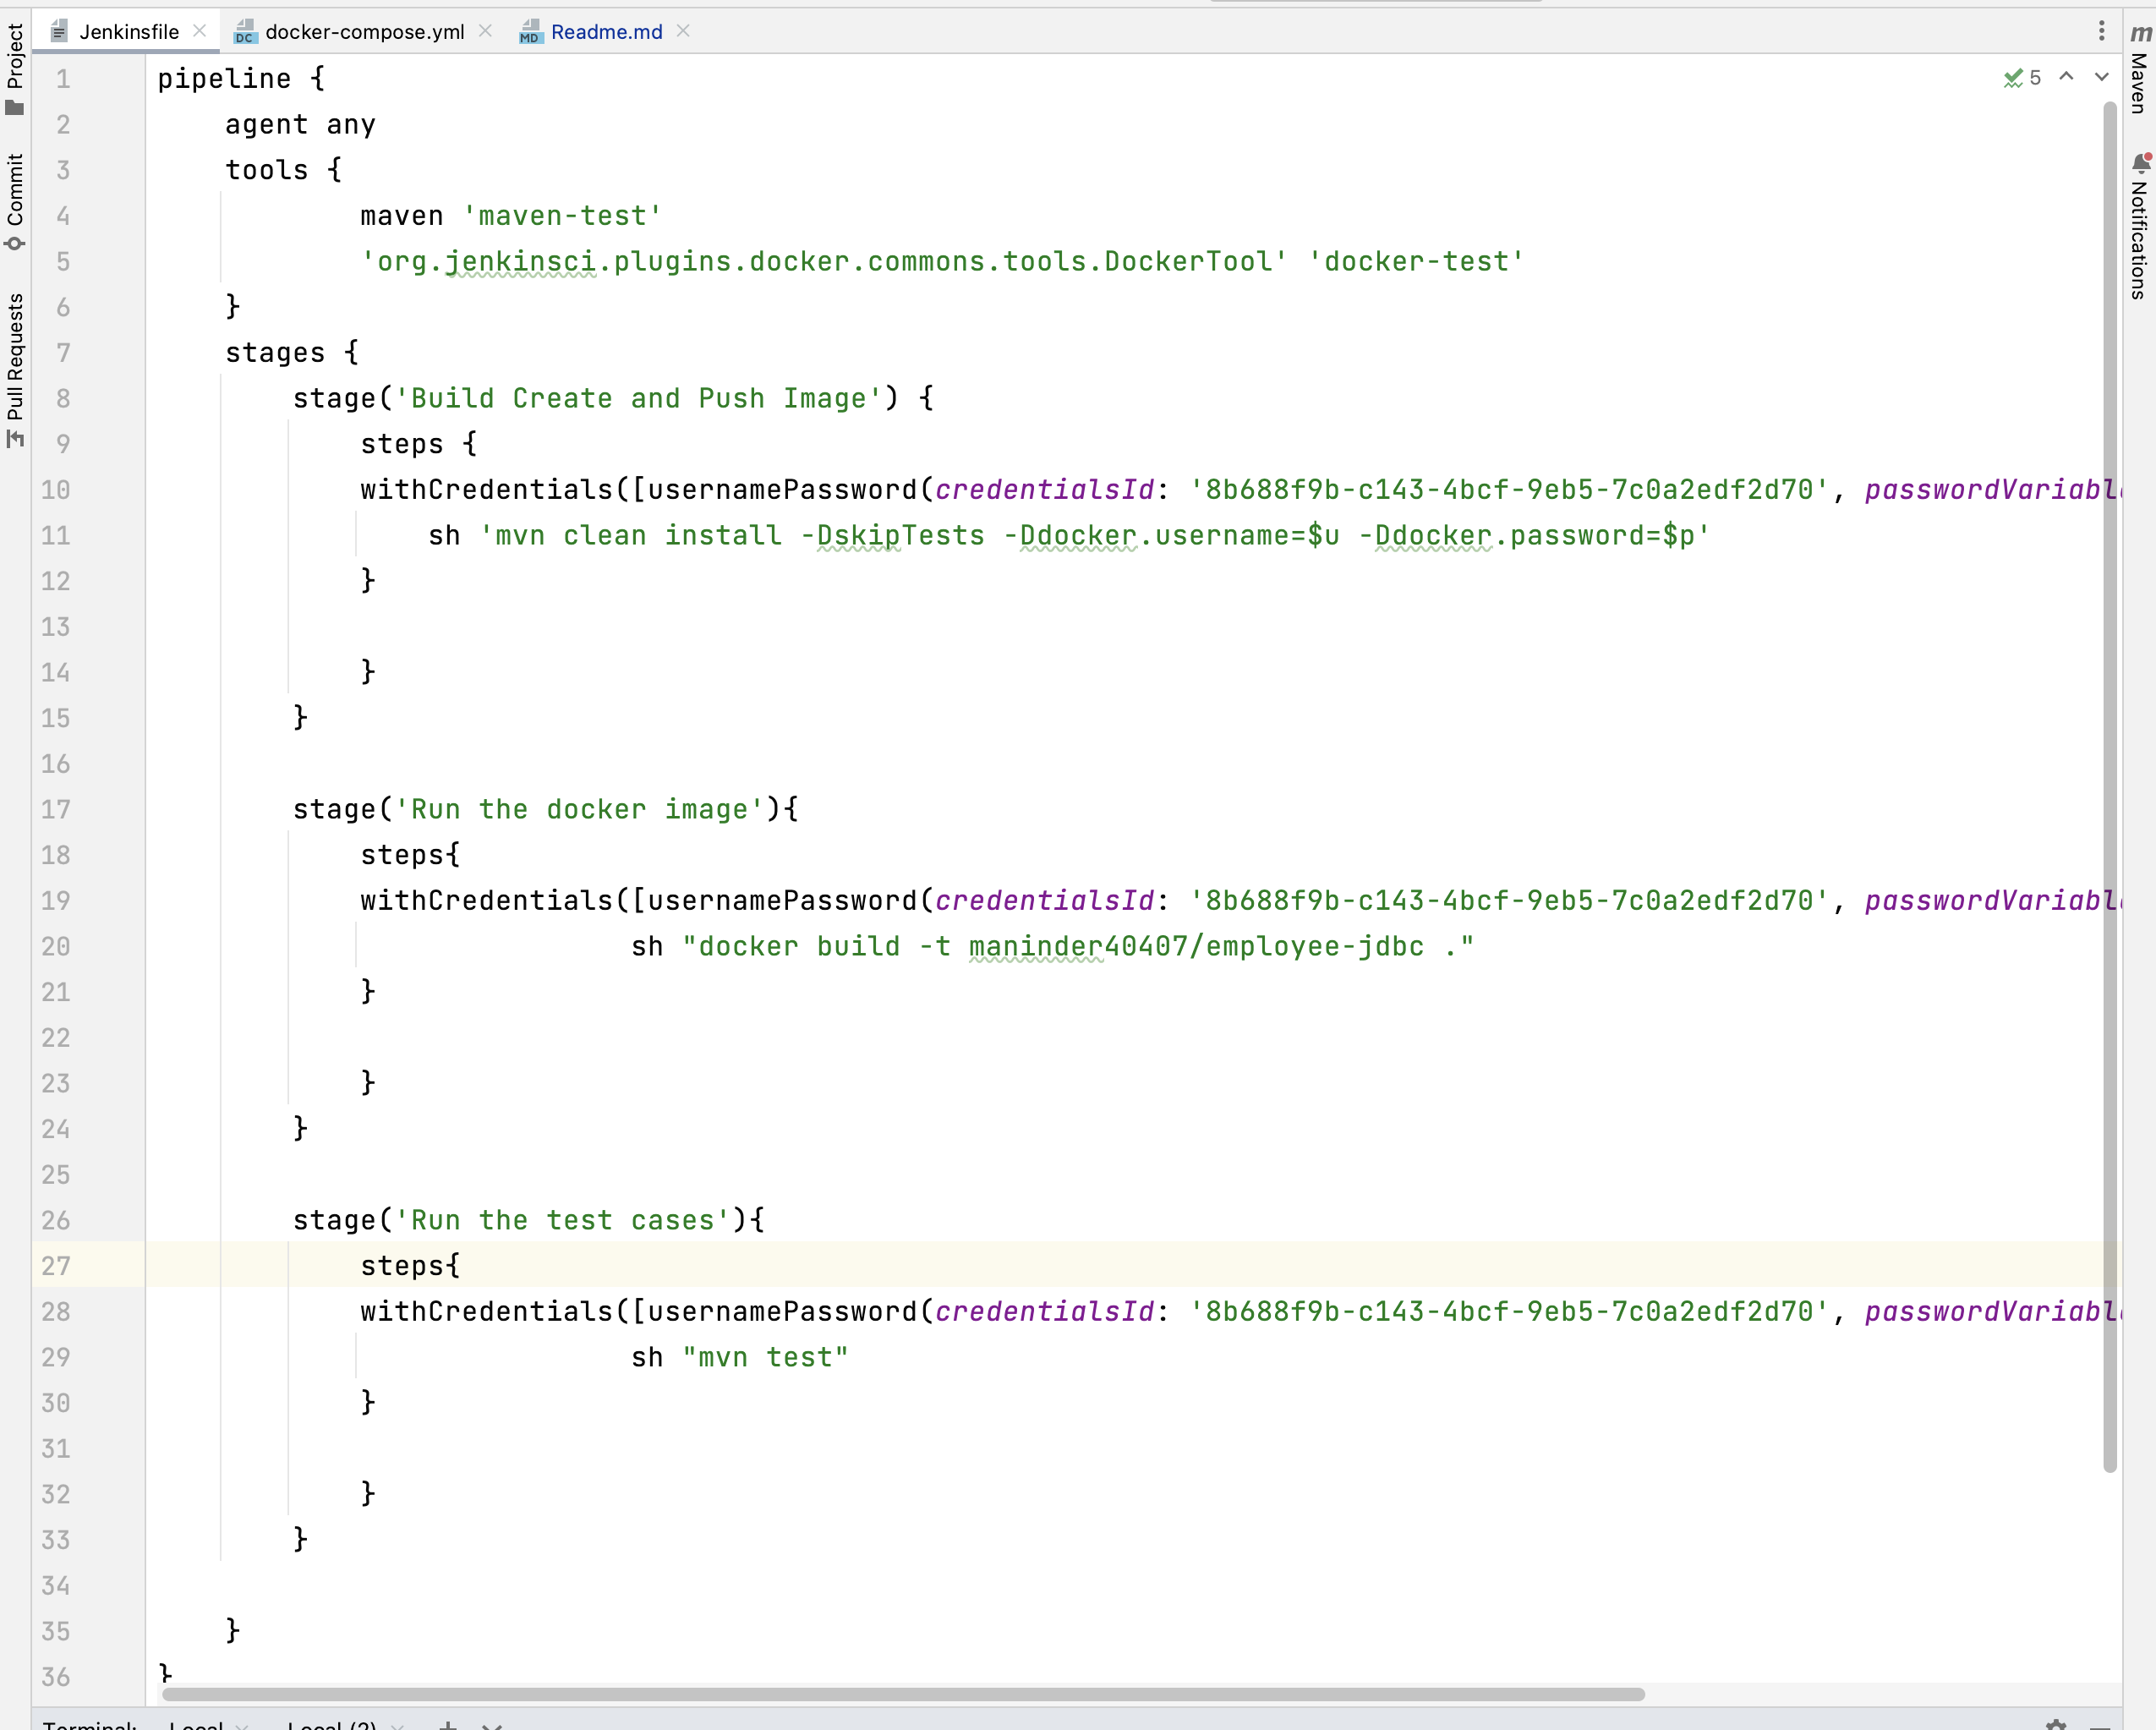

Jenkins file looks like. The “**withCredentials code**” you can generate:

Go inside the “dashboard->your pipeline->go down” and click on “**Pipeline syntax**”.

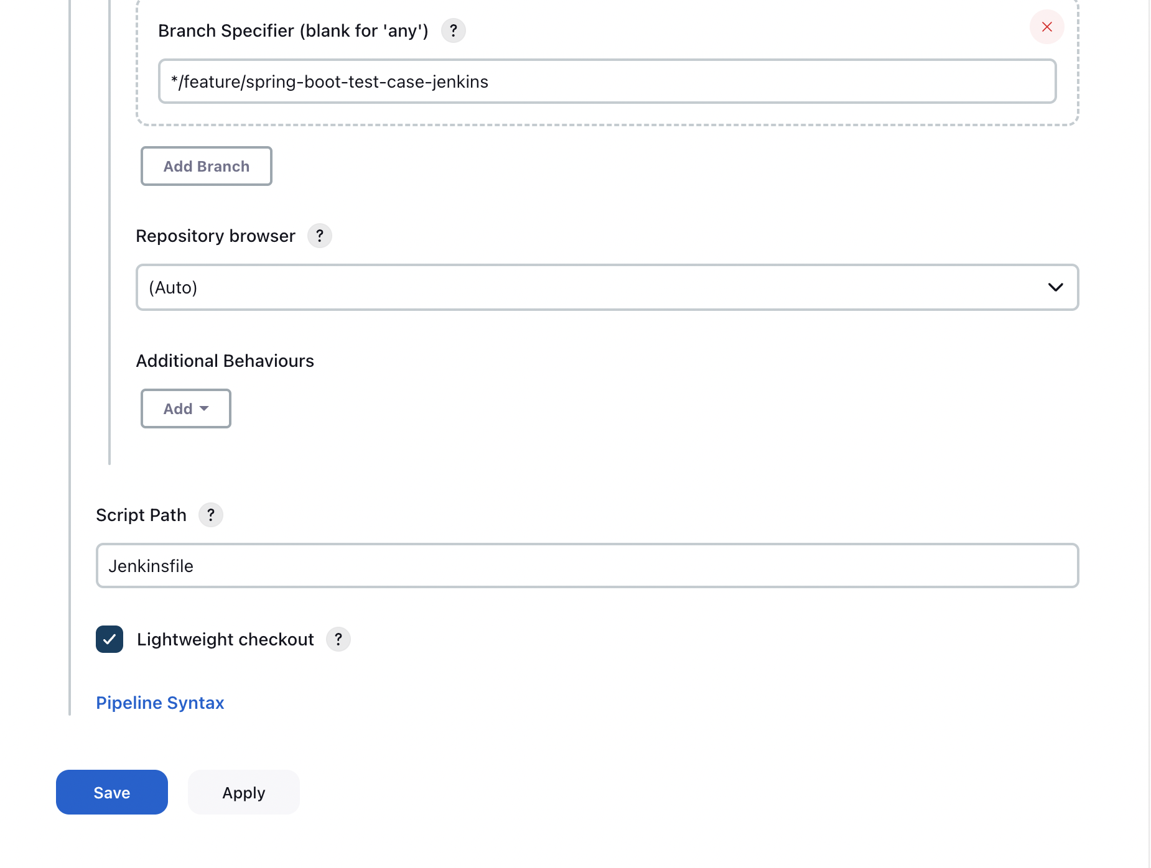

**Choose “withCredentials: Bind credentials to variables”!**

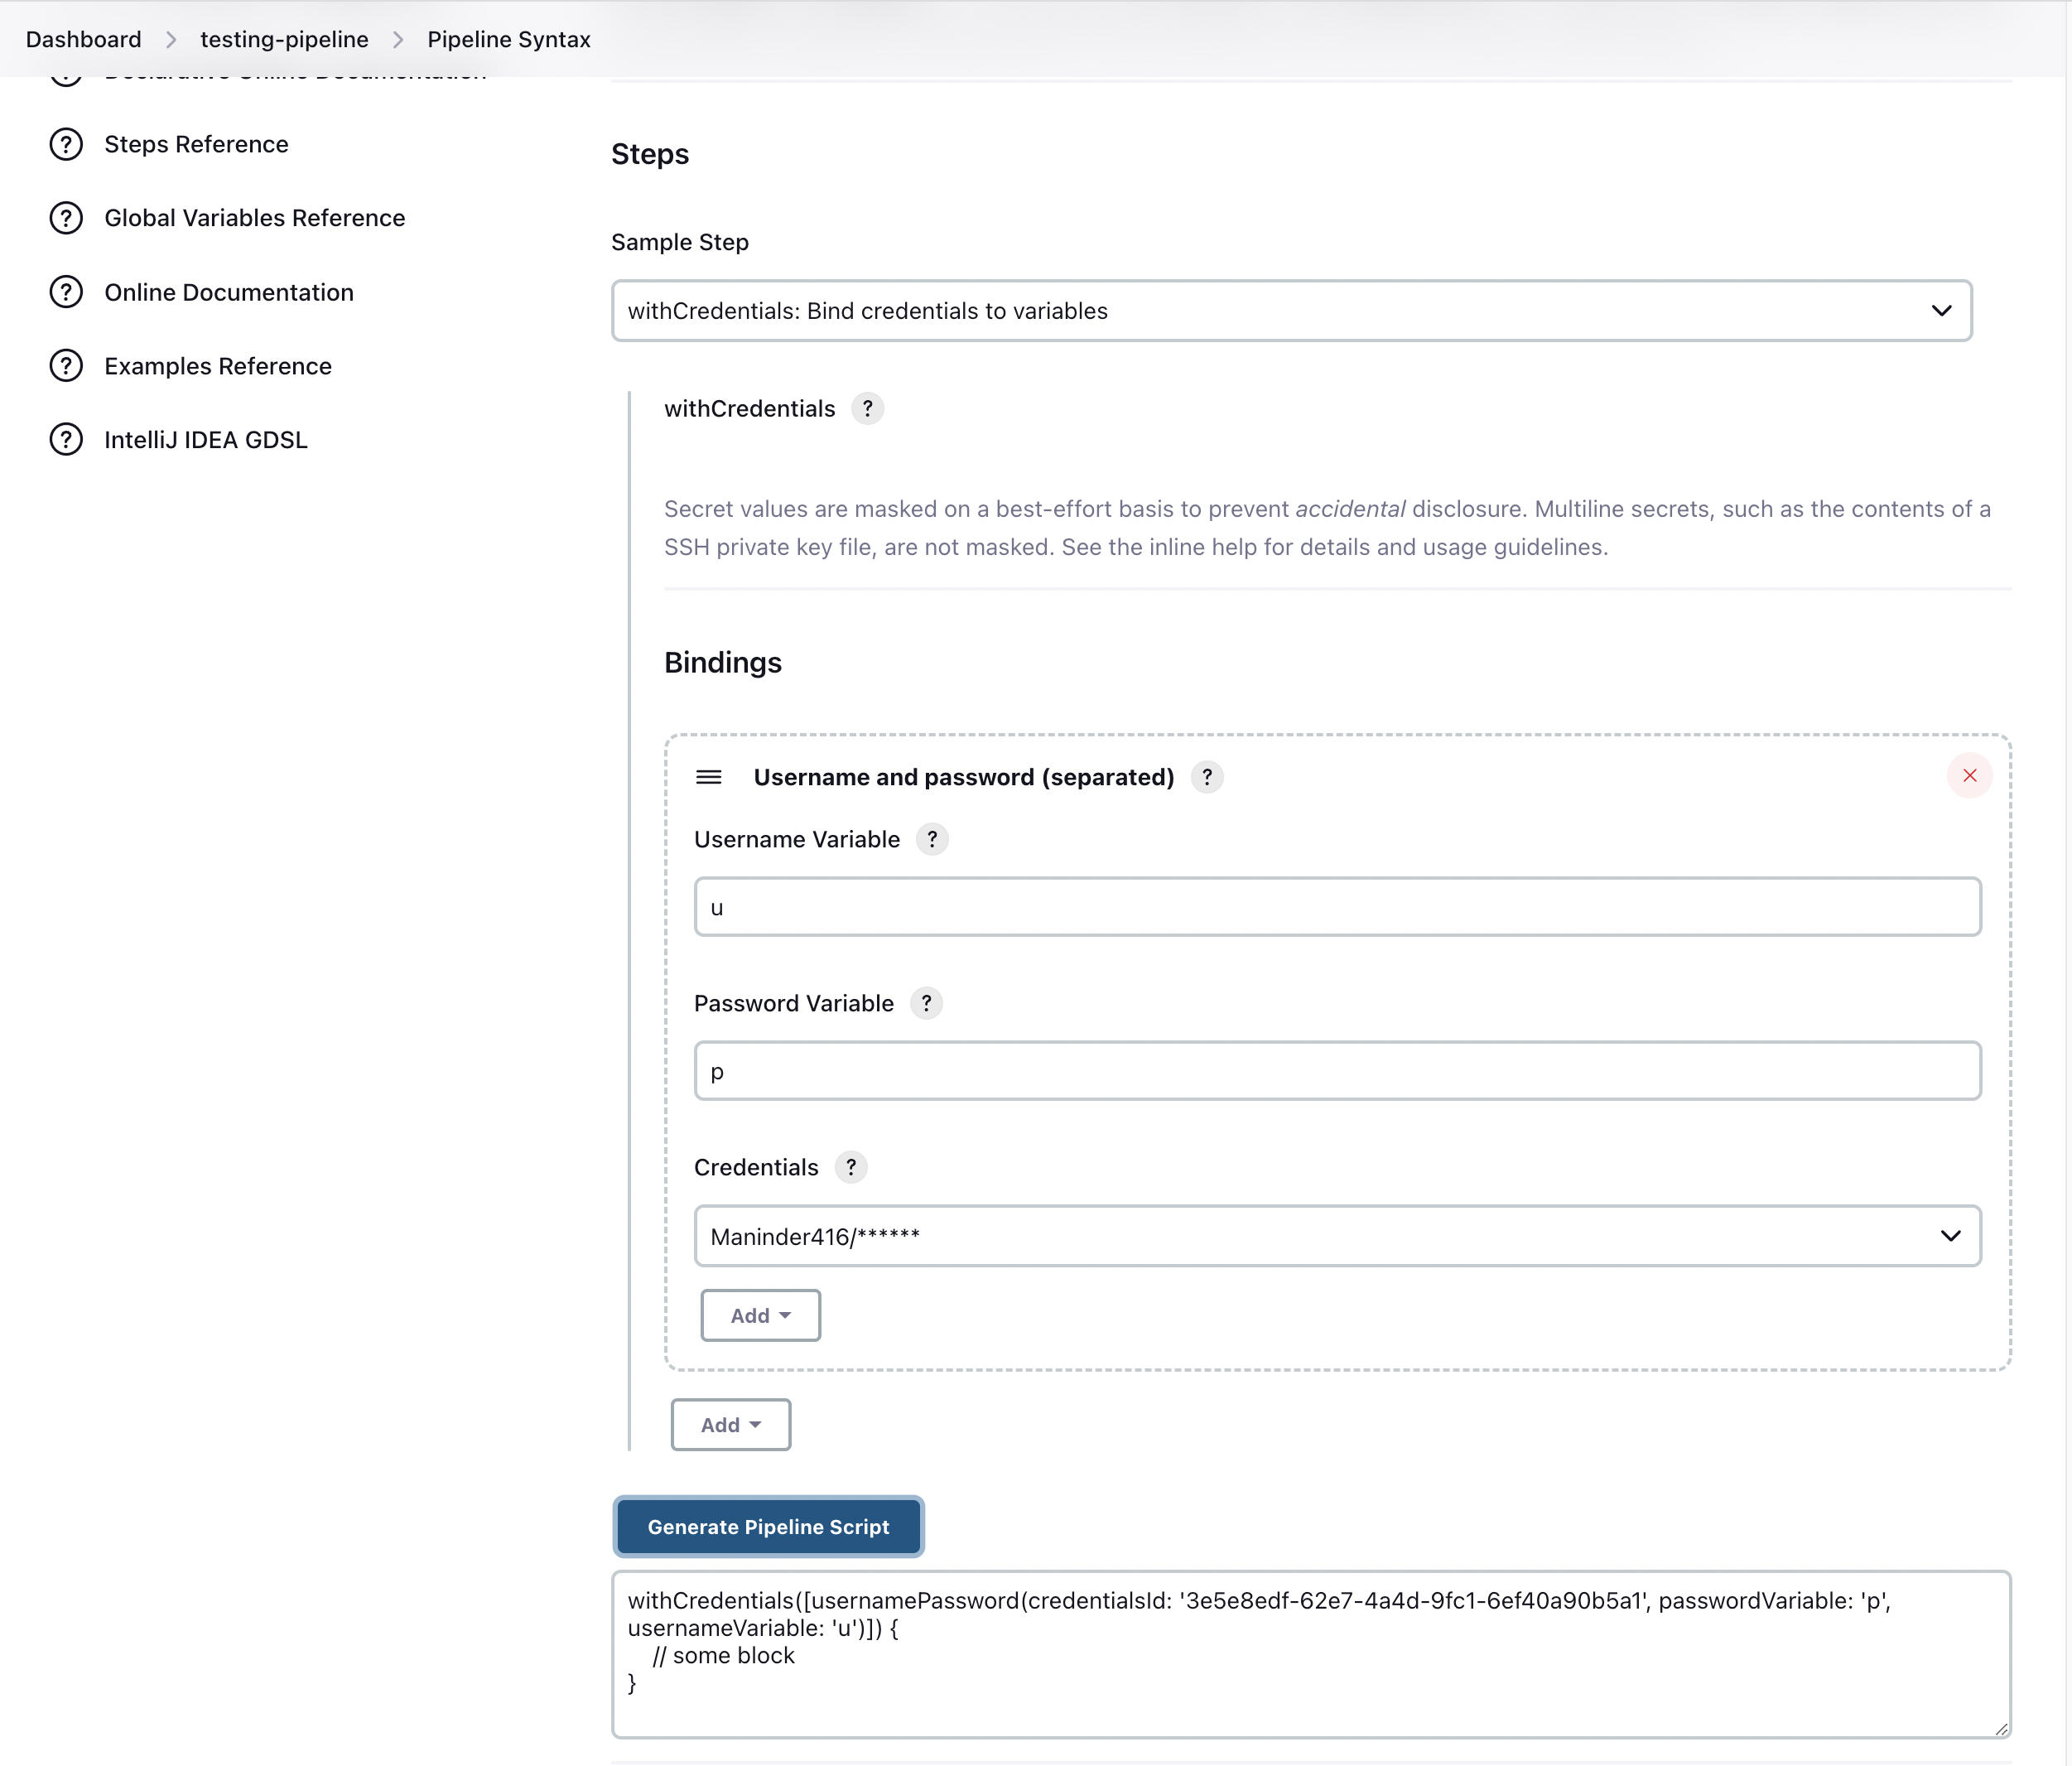

In here, we assigned username variable as “u” and password variable as “p” and just copy paste this into our Jenkins file:

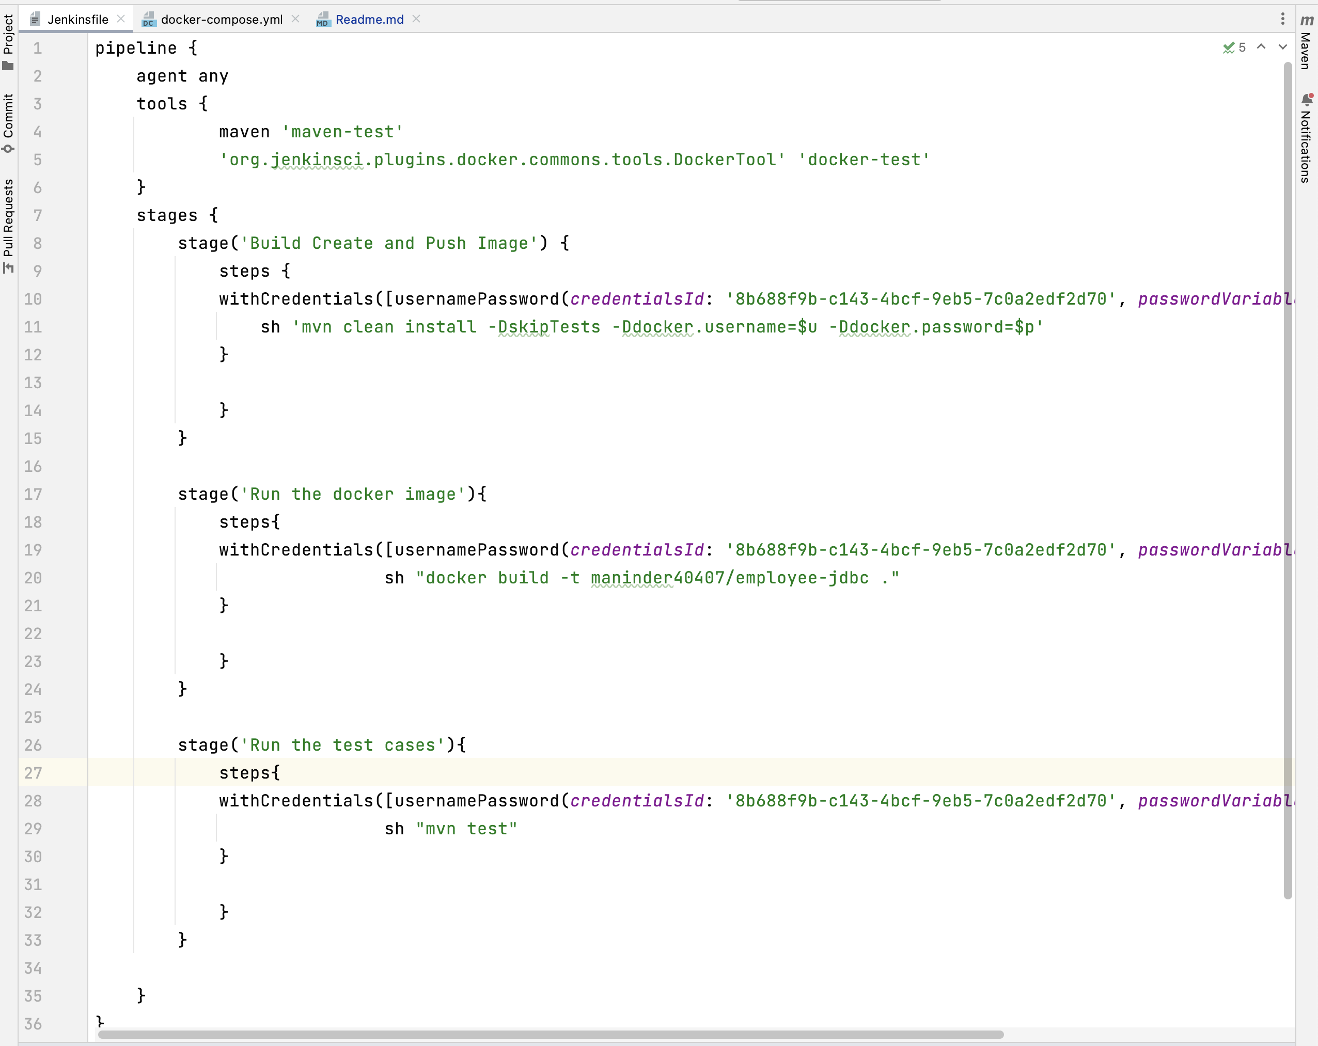

It will pick username and password automatically.

Commit and code and build the pipeline and observe the results:

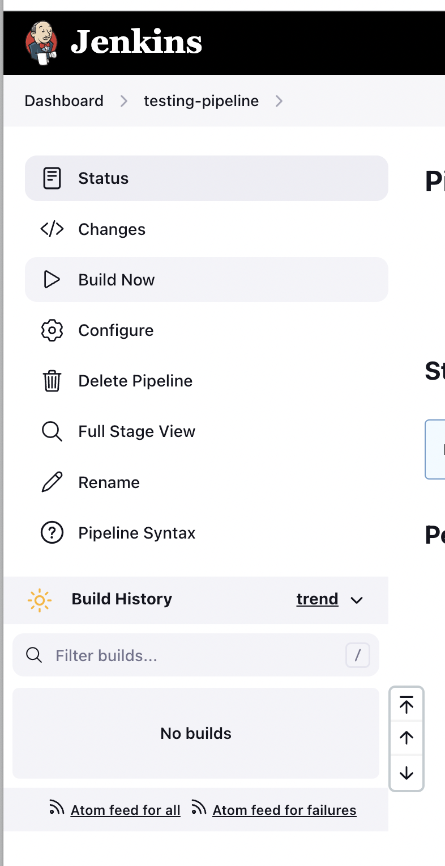

Click on “Build Now option”

It will run the build on pipeline.

